FIKSPOINT DEALERSHIP
1. WEBSITE SPECIFICATION
The FIKSPOINT DEALERSHIP website will be an E-commerce and listing Website displaying multiple cars with detailed information.
OBJECTIVE: The main objective of this website is to advertise, sell, and book services for cars.
GOALS:
- Reaching a wider audience including those far from the dealership.
- Inquiries, bookings, and test drive requests.
- Communicate prices, vehicle availability and models available.
- Provide customers with a platform which they can browse cars anytime and anywhere.
- Regular customers being able to book for their vehicle services and upgrades
TARGET AUDIENCE:
-Income: Middle to upper middle class
-Age (18years and above)
-Interests (People looking for brand new/used vehicles, people servicing their vehicles)

2. INFORMATION DESIGN & TAXONOMY:
- Home
- Service Bookings
- Car listings
- About us
- Contact us
- Login
TECHNICAL APTITUDE:
- Computer or smartphone literate
-Being able to fill online forms
-Comfortable browsing the internet
3.PAGE TEMPLATE DESIGN
CONTACT US PAGE

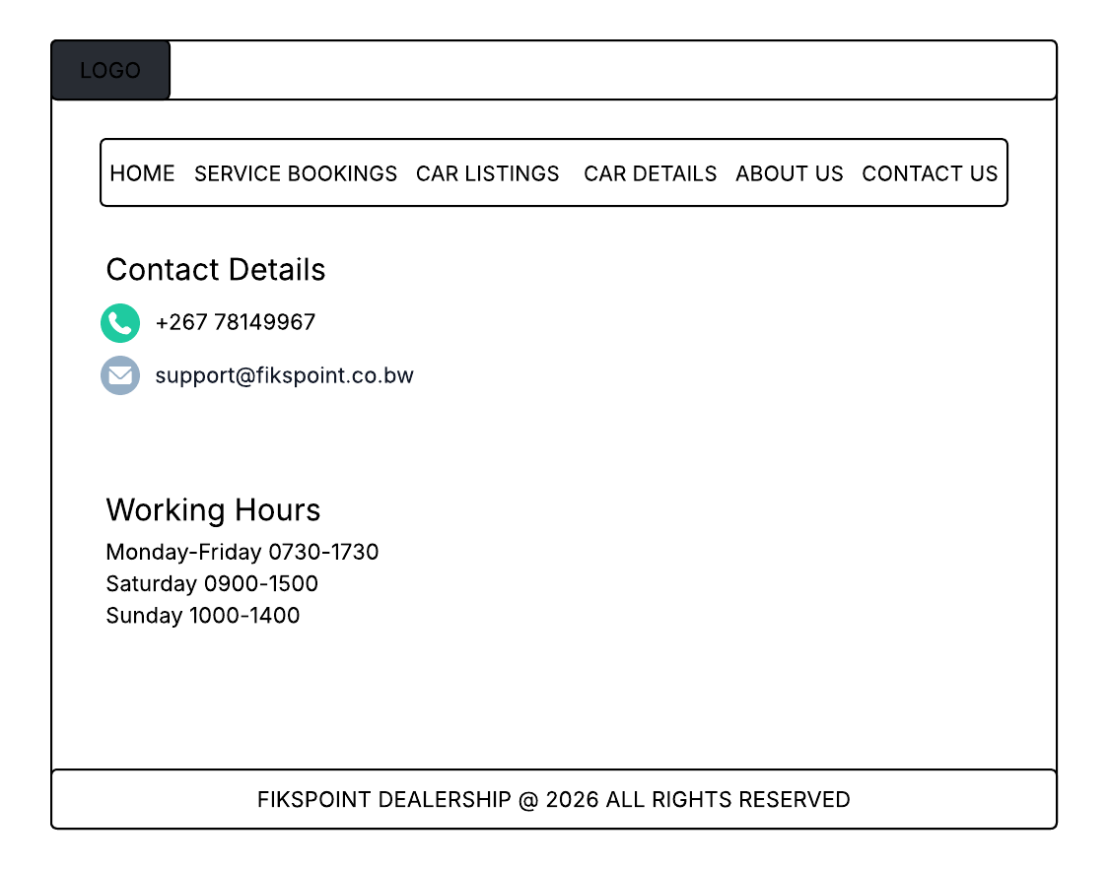

ABOUT PAGE
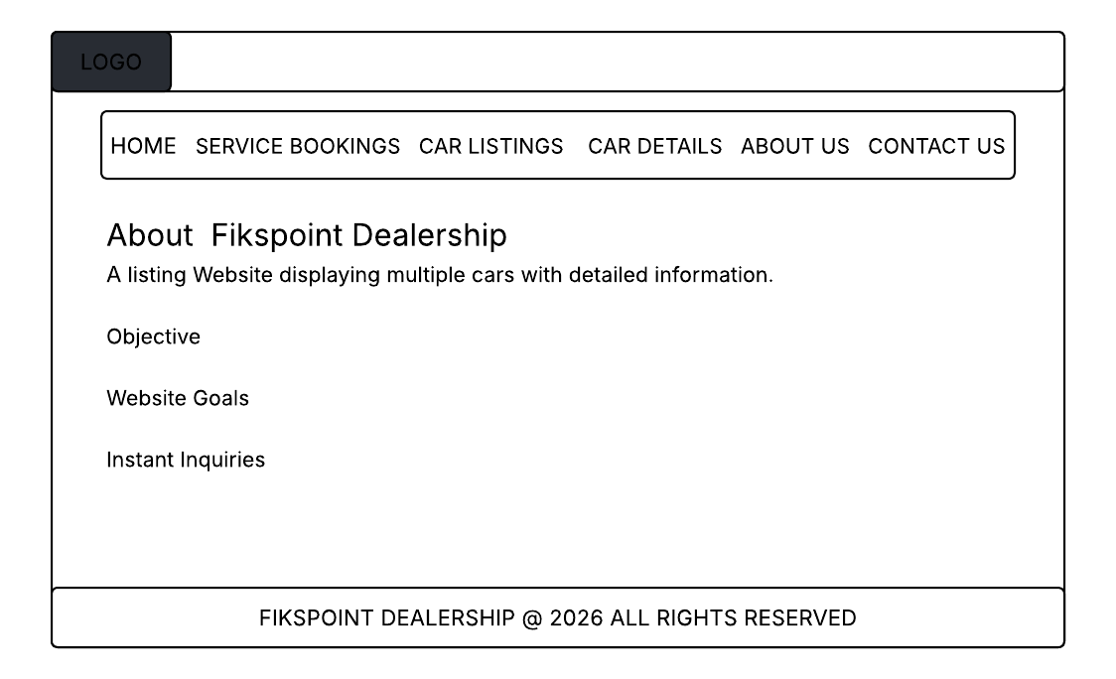

SERVICE BOOKINGS PAGE
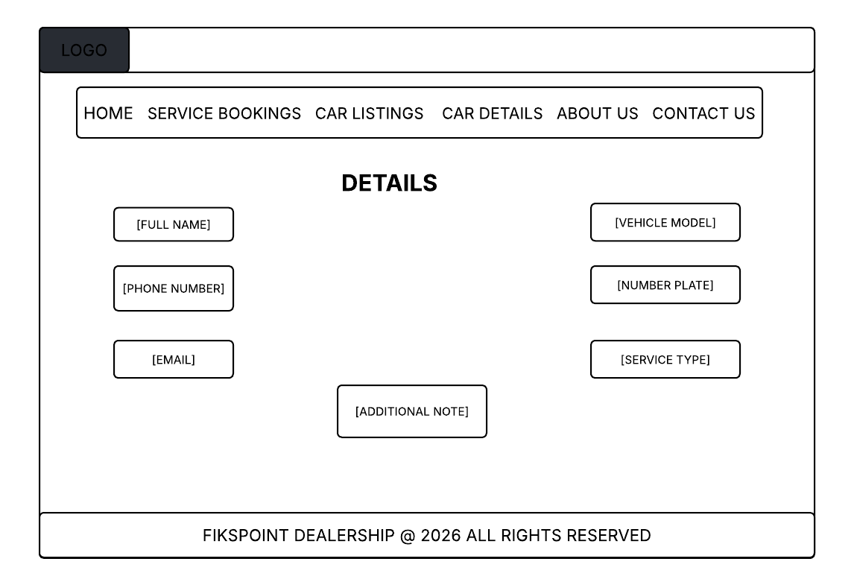

CAR LISTINGS 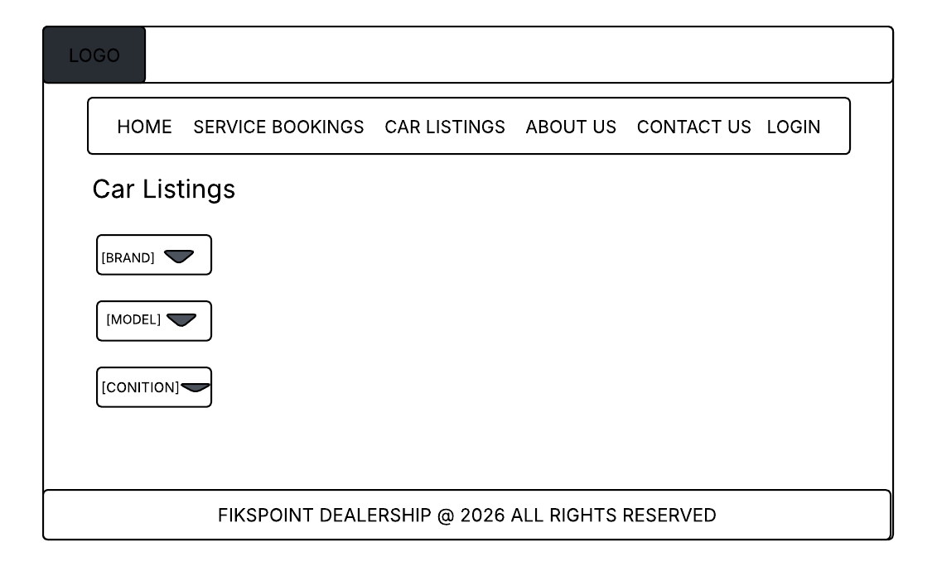
LOGIN
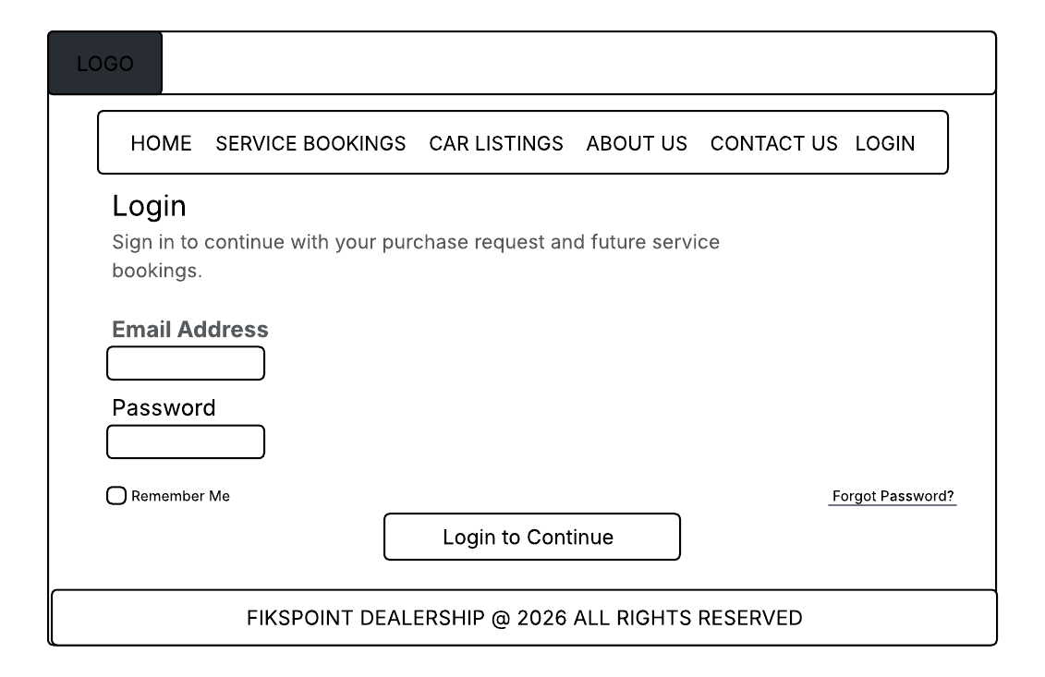
HOME PAGE
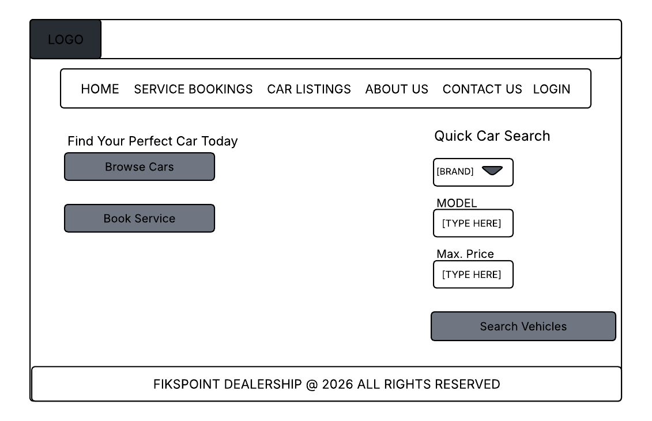

4.TECHNICAL BRIEF
FRONT-END TECHNOLOGIES
- HTML5- Will be used for structuring the content of the website.
- CSS-Used for styling
- BOOTSRAP- helps create a quick response to clients
DEVELOPMENT TOOLS
- VISUAL STUDIO CODE- For writing codes
- GITHUB- For storing and managing code versions
DESIGN AND GRAPHIC TOOLS
- ADOBE PHOTOSHOP- For editing car images and banners

5. QUALITY ASSURANCE
Tests Conducted:
- Browser testing in Chrome and Microsoft Edge
- Navigation links
- Mobile navigation menu

6. PUBLISHING AND PROMOTION
HOSTING METHOD- The website is hosted in GitHub pages.
TOOLS USED:
GITHUB-For storing and managing the website files
VISUAL STUDIO-For writing codes
CHROME WEB BROWSER- For testing the live web

7. FUTURE DEVELOPMENTS/RECOMMENDATIONS:
Even though the website meets its current objectives, there are several improvements that can be implemented in the future to enhance functionality and user experience. Below are some of the features that can be improved:
-More detailed features such as transmission mode and fuel type.
-Introduction of secured online full payments.
-Allow users to create profiles for easily access.
-Develop a mobile app for mobile users.
-Introduction of live-chat feature for real-time communication.

